Nackawic Elementary School 2026-2027
Grade 1 Cernivz School Supply List
- 3 packages of Crayola Original 10 markers
- 2 packages of Crayola Crayons 24 pack
- 8 fine tip whiteboard/dry erase markers
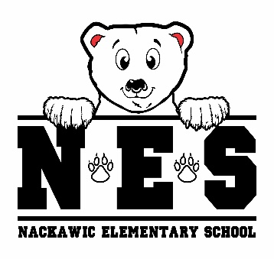
- 18 Nordica Staedtler pencils
- 1 plastic pencil storage box
- 1 large glue stick
- 3 Hilroy exercise book - green (½ blank / ½ primary lined)
- 6 – 2 pocket portfolio covers- red, blue, green, yellow
- 20 plastic page protectors
- 2 duotangs (red, green)
- 1 composition book- black 192 pages
- 2 white erasers
- 1 zipper pouch for communication bag large enough to fit a duotang
- 2 sharpies
- 1 pair of indoor sneakers – Velcro if not able to tie
- lunch box & bookbag
- 1 reusable water bottle
- over the ear headphones
- 2 boxes tissues
- resealable zipper bags – 1 large pkg / 1 small pkg
- 2 packages of disinfectant wipes
- Change of clothes in plastic bag labeled with your child’s name (socks, underwear, shorts, t-shirt, pants)

$25 Student Fee (to be paid by September 30, 2026)

(please clearly label lunch box, bookbag, headphones, change of clothes, water bottle & sneakers)

