Nackawic Elementary School 2026-2027
Grade 2 (FI) School Supply List
- 2 packages of 10 markers
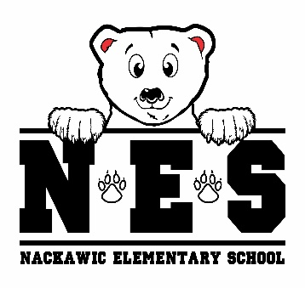
- 12 whiteboard/dry erase markers
- 24 Nordica Staedtler pencils
- 1 pencil sharpener
- 2 white erasers
- 1 plastic pencil box
- 1 Hilroy 4pk Canada Notebooks
- 3 large glue sticks
- 1 Hilroy exercise book (½ blank / ½ primary lined, green cover)
- 2 pocket portfolio covers (red and black)
- 30 plastic page protectors
- 4 duotangs (orange, yellow, green, red)
- 1 zipper pouch for communication bag large enough to fit a duotang
- 1 inch binder (red)
- 2 sharpies
- 1 pair of indoor sneakers
- lunch box & bookbag
- 1 reusable water bottle
- 1 pair of earbuds/headphones
- 2 boxes tissues
- resealable zipper bags (1 small pkg / 1 large pkg)
- 2 packages of disinfectant wipes

- $25.00 Student Fee to be paid by September 30, 2026

(please clearly label lunch box, bookbag, change of clothes, water bottle & sneakers)

