Nackawic Elementary School 2026-2027
Ms. Michaud’s Grade 3 School Supply List
- 1 plastic duotang with pockets
- 2 writing folder with pockets
- 1 package of Hilroy loose-leaf paper
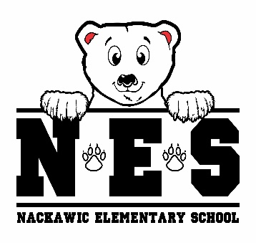
- 3 duotangs (1 of each color: green, yellow, red)
- 1 pencil sharpener (Steadtler enclosed sharpener)
- 20 clear plastic page protectors
- 5 subject dividers
- 1 package of 24 Crayola pencil crayons
- 2 packages of 10 pack of Crayola washable markers
- 1 zipper pencil case
- 1 hard plastic pencil box
- 24 Nordica Steadtler Mars Norica pencils (blue ones)
- 1 large glue stick
- 4 white vinyl erasers
- 4 Expo whiteboard/dry erase markers
- 1 clipboard
- 2 black sharpies
- 1 liquid glue
- 2 packages of Hilroy notebooks
- 1 pair of indoor sneakers
- lunch box & bookbag
- 1 reusable water bottle
- 1 pair of earbuds/headphones
- 2 boxes tissues
- resealable zipper bags (1 small / 1 large)
- 1 packages of disinfectant wipes

- $25.00 Student Fee to be paid by September 30, 2026

(please clearly label: lunch box, bookbag, water bottle & sneakers)

