Nackawic Elementary School 2026-2027
Grade 4-5 (FI) Adams School Supply List
- 3 – 1” hard-cover binders (3 different colors: Black, Blue, Red)
- 1 package of Hilroy loose-leaf paper
- 2 duotangs (1 of each color: yellow, green)
- 1 pencil sharpener (Steadtler enclosed sharpener)
- 2 packages of clear plastic page protectors
- 10 subject dividers
- 1 package of Crayola pencil crayons
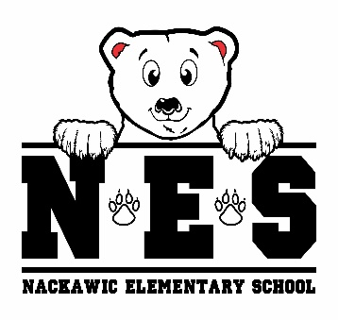
- 1 package of Crayola washable markers
- 1 hard plastic pencil box
- 24 Nordica Steadtler Mars Norica pencils (blue ones)
- 1 large glue stick
- 2 white vinyl erasers
- 4 Expo whiteboard/dry erase markers
- 2 black sharpies
- 1 pair of scissors
- 1 package of Hilroy notebooks
- 1 pair of indoor sneakers
- lunch box & bookbag
- 1 reusable water bottle
- 1 pair of earbuds/headphones
- 2 boxes tissues
- resealable zipper bags (1 small pkg / 1 large pkg)

- $25.00 Student Fee to be paid by September 30, 2026

(please clearly label: lunch box, bookbag, change of clothes, water bottle & sneakers)

