Nackawic Elementary School 2026-2027
Grade 4 MacFarlane School Supply List
- 1 – 1” hard-cover binder
- 1 package of Hilroy loose-leaf paper
- 1 package of 4 Hilroy notebooks
- 5 duotangs (1 of each color: orange, black, green, yellow, red)
- 1 package of 12 Crayola Fine Tip washable markers
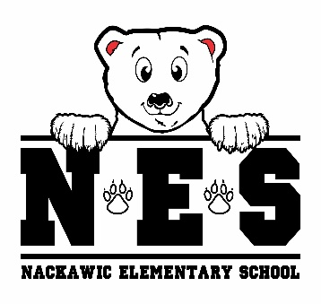
- 1 package of 10 Crayola Fat Washable markers
- 1 package of 12 Nordica Staedtler pre-sharpened pencils (blue)
- 1 zipper pencil case
- 1 hard plastic pencil box
- 2 large glue sticks
- 2 white vinyl erasers
- 4 Expo whiteboard/dry erase markers (Fine tip)
- 1 Expo dry erase chisel tip marker - black
- 2 black sharpies
- 1 package of highlighters
- 1 clipboard
- 1 pair of indoor sneakers
- lunch box & bookbag
- 1 reusable water bottle
- 1 pair of earbuds/headphones
- 2 boxes tissues
- resealable zipper bags (1 small (sandwich size) / 1 large)
- 1 package of disinfectant wipes

- $25.00 Student Fee to be paid by September 30, 2026

(Please clearly label lunch box, bookbag, change of clothes, water bottle & sneakers)

