Nackawic Elementary School 2026-2027
Grade K Coulter School Supply List
- 1 box of 24 Crayola pencil crayons
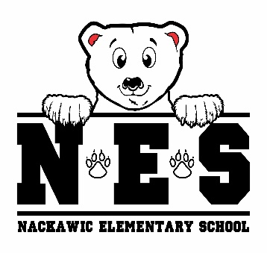
- 1 package of 10 Crayola markers (thick)
- 1 package of 16 Crayola markers (thick)
- 1 package of 12 fine line Crayola markers (thin)
- 12 Expo dry erase markers
- 1 double sided whiteboard/learning board (8.5X11)
- 2 permanent black Sharpie marker
- 18 Nordica Staedler pencils
- 1 pencil sharpener
- 2 white Staedtler erasers
- 1 large yellow UHU glue stick (40 grams)
- 1 yellow Hilroy exercise book (½ blank / ½ lined pages)
- 2 plastic Duotang Report cover (1 red and 1 blue)
- 4 duotangs (black, blue, yellow, orange)
- 1 pair of indoor sneakers – Velcro or slip on only please
- lunch box & bookbag
- 1 reusable water bottle
- over the ear headphones
- 2 boxes tissues
- resealable zipper bags – 1 large pkg/ 1 small pkg
- change of clothes in plastic bag labeled with your child’s name

$25 Student Fee (to be paid by September 30, 2026)

(please clearly label lunch box, bookbag, headphones, change of clothes, water bottle & sneakers)

